**How are the Versions and Aliases working with together? And How Linear & Canary testing is working with Lambda functions)**

1. **Demo with Versions and Aliases**
2. **Create a dummy lambda with Python3.0**

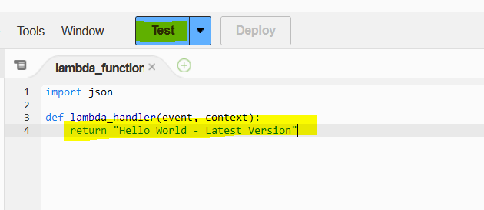

Then test it

This function doesn’t have versions and aliases

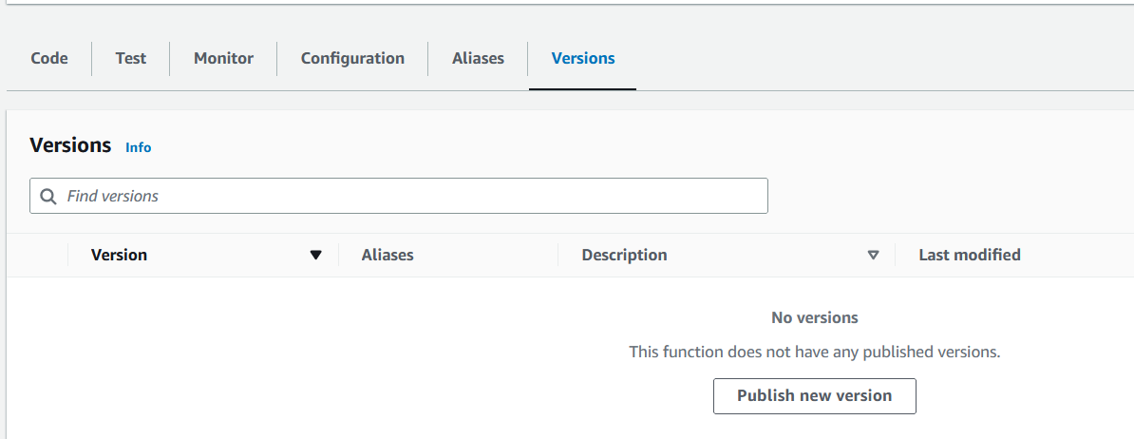

1. **Publish Version-1**

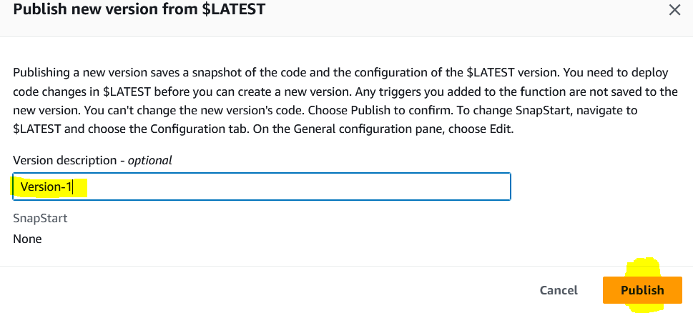

Version-1 has own Amazon Resource Name (ARN) and function has been changed to Version-1

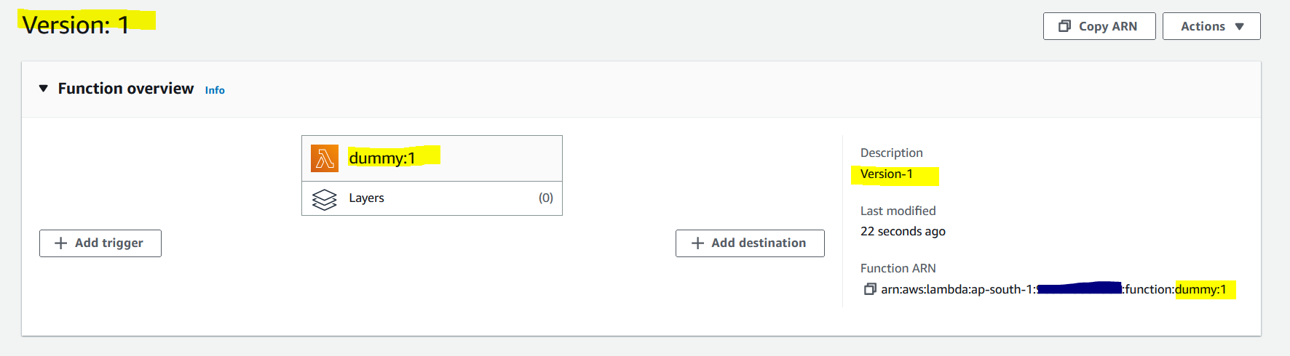

But Version-1 code can’t be changed or updated. Because its Immutable.

So Version-1 has no option to deploy the code in anyway

If you want to change the code, then go back to Latest Version and update the code.

1. **Publish Version-2**

Go back to Latest version and update the code and publish a Version-2

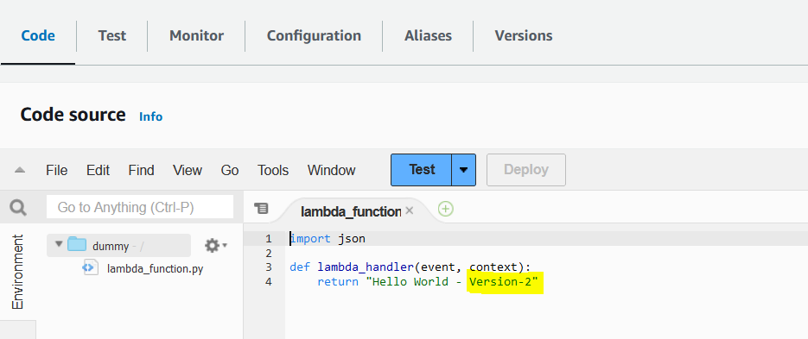

After published the code, test it from Version-2

1. **Create an Alias**

Go back to Latest Version and create an Alias as DEV and Point with Latest Version

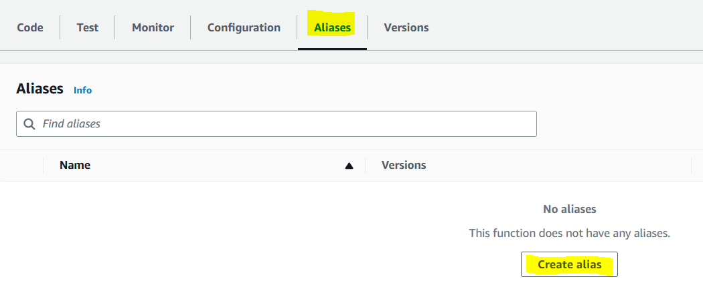

So, the DEV (Alias) is mapped to Latest Version of the Lambda Function

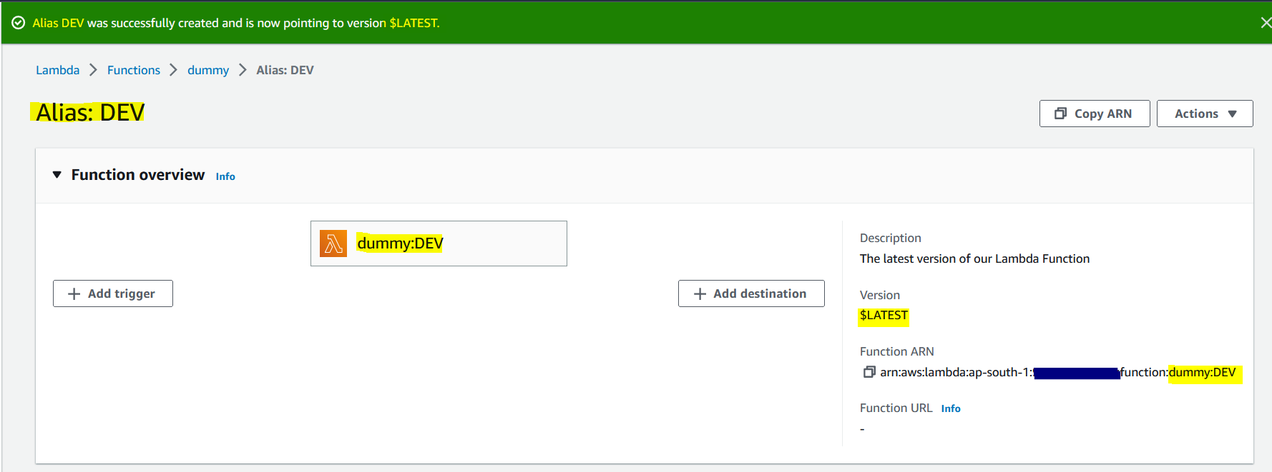

As well, the Alias has own ARN (Amazon Resource Name)

1. **Test with DEV Alias**

Go back to the Latest Version and test the code

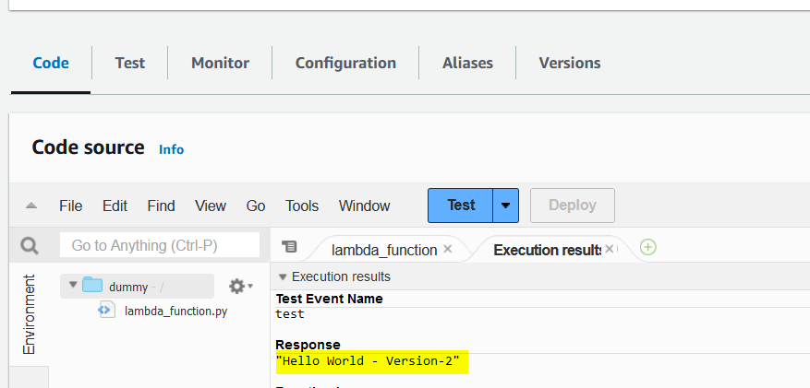

Then choose the DEV Alias and test the code

We will have the same output for both Latest Version and DEV Alias. Because Alias is mapped to the Latest Version.

1. **Create a PROD Alias**

Go back to the Latest Version and create one more Alias as PROD, then mapped this PROD Alias to Version-1

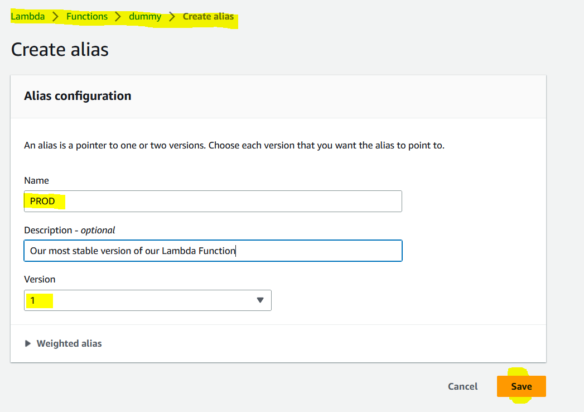

So, PROD Alias is mapped to the Version-1, and it has own ARN

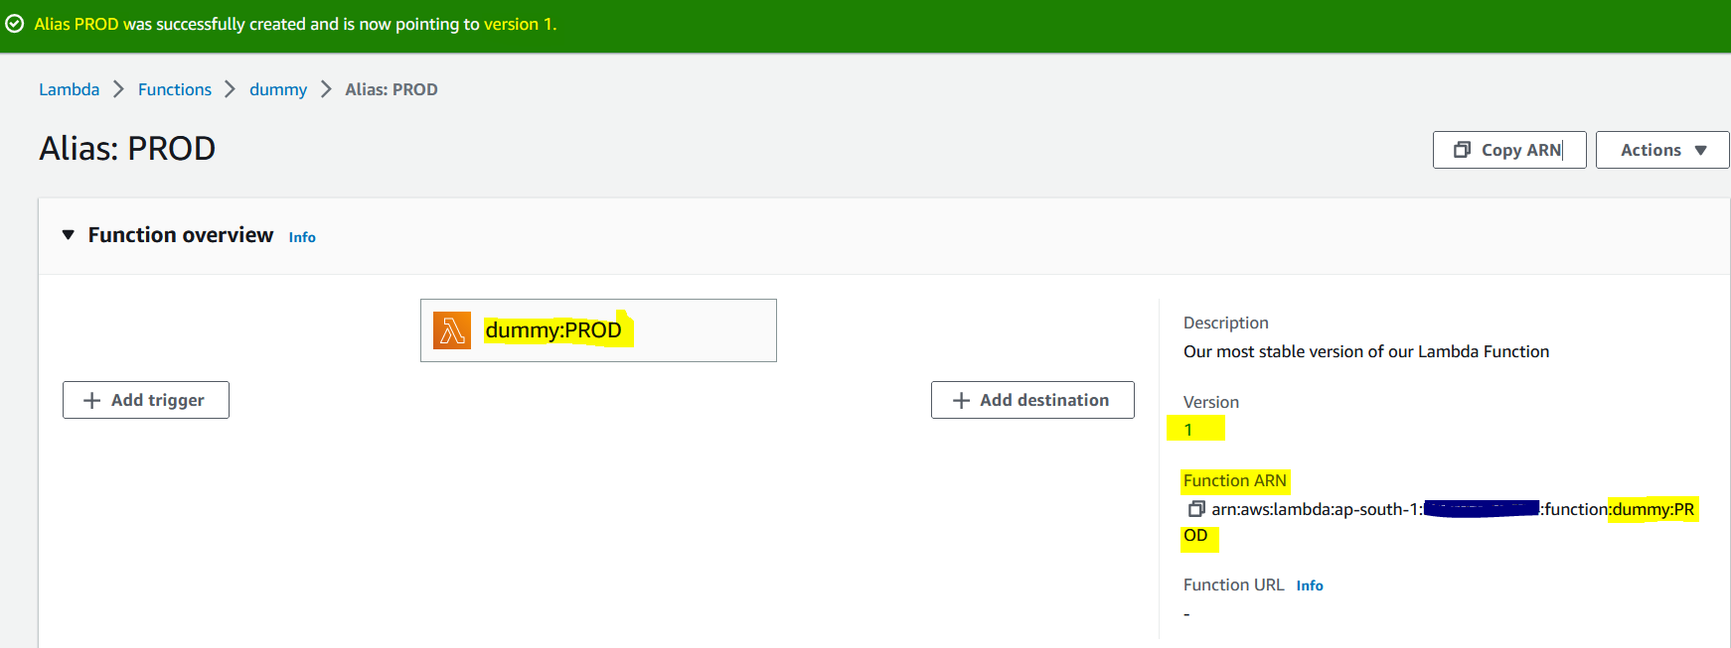

1. **To test with Linear Method (Blue – Green Deployment)**

Go back to Latest Version, and Select PROD Alias and edit the weighted policy

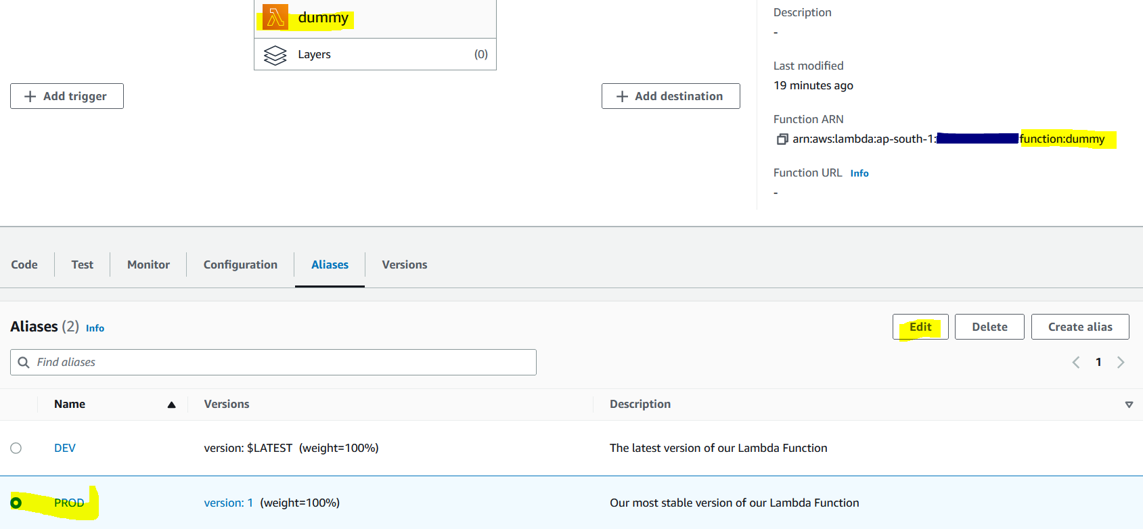

Edit

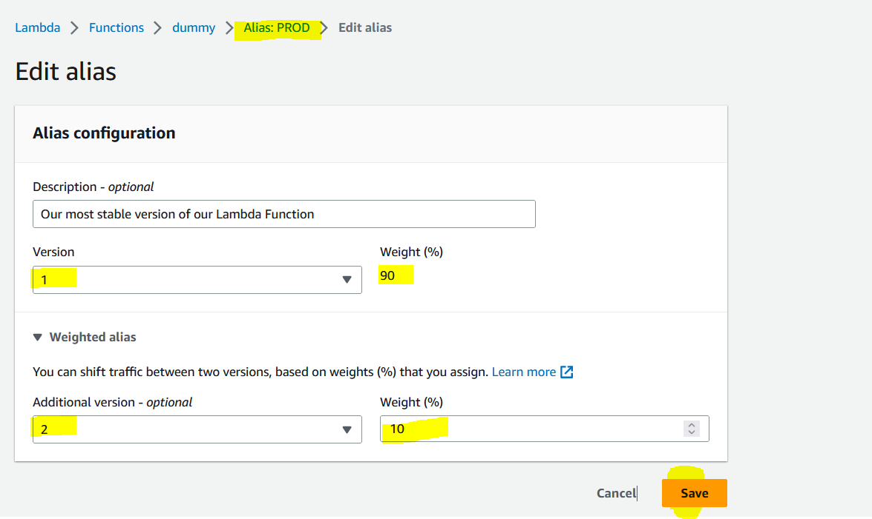

So, what happened is, 90 % traffic serving to version 1 and 10 % traffic serving to version 2. (Its like a blue-green deployment)

To change the weighted policy 50-50. So every request has been sent to each Version 1 & 2.

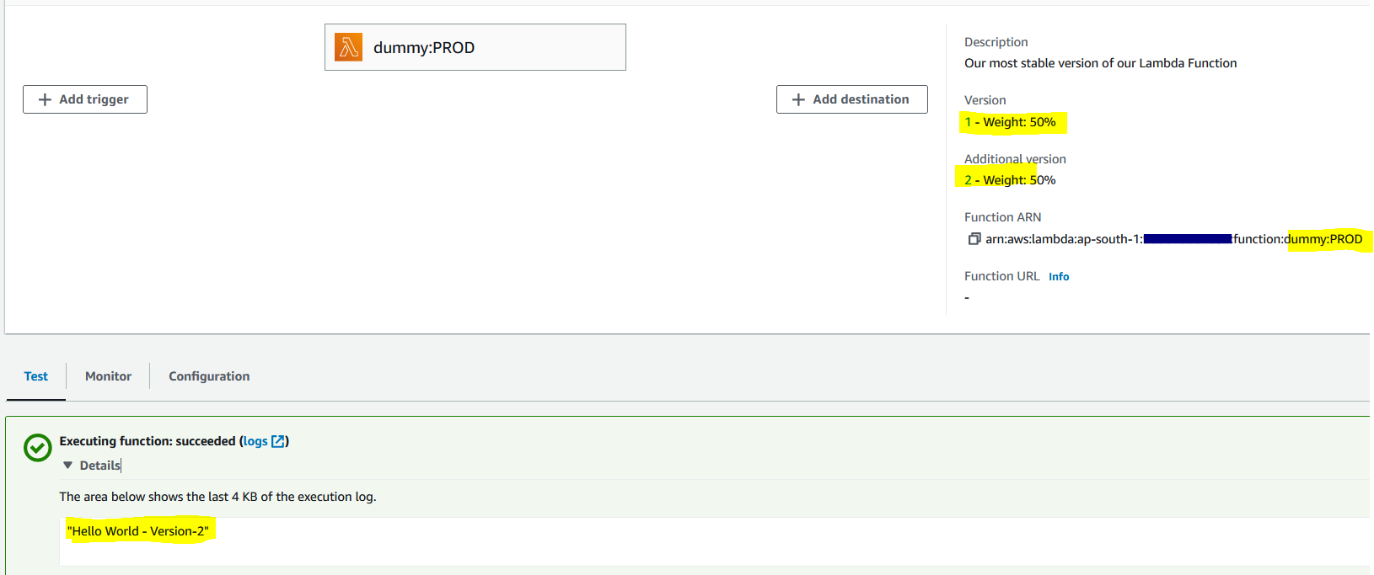

Next test will be.

This is linear method (like increasing gradually – 10% 30% 50% 70% 90% 100%) whereas Canary step is based (like first 20 % then 100 %)